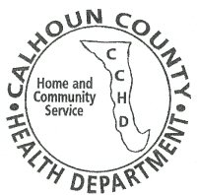
Calhoun County Health Department
210 French Street, PO Box 158
Hardin, IL 62047
Phone: (618) 576-2428
Fax: (618) 576-9808
March 19, 2020

Dear Calhoun County Residents,

Beginning on Monday, March 23, 2020, Calhoun County Health Department lobby will be closed to walk-ins, until further notice. This is to ensure the safety of our staff, clients and community. The office hours will remain the same, 8am to 4pm Monday through Friday, closed from 12pm to 1pm for lunch. CCHD will continue to be available by phone and can be reached at 618-576-2428. Immunizations will be given by appointment only and clients will be screened for illness prior to receiving service.

All WIC/FCM appointments will be completed via phone with WIC coupons being picked up curbside. Further guidance will be provided during phone appointment.

If you have any questions or concerns, please feel free to contact the Calhoun County Health Department.

Sincerely,
Calhoun County Health Department

